Objective

Define mechanisms to assure the Help System and the training materials continues operating correctly, including changes, enhancements, errors correction and documentation kept up-to-date.

Scope

All products that will compound the Help system for the BCH web site.

References

HELP: (Innovasy Help Studio System):
http://www.innovasys.com/

Moodle
http://moodle.org/

Adobe
http://www.adobe.com/

DEV.IN.01 Versions and Builds
DEV.PR.01 Importing documents into Help Studio
DEV.PR.03 Working with Build Flags and Build Profiles
DEV.PR.05 PDF Generation
DEV.PR.06 Update the CD-ROMs ISO
DEV.REP.04 Training material list

Definitions

Managing versions
The document changes are usually identified by incrementing an associated number or letter code, termed the "revision number", "revision level", or simply "revision" and associated historically with the person making the change.(DEV.in.01.Versions and Builds). Each time a document is modified, the previous version of the document is kept and the new version is labeled with the next revision number. Only the latest version is readily available; however, any previous version can be restored at any time so as to undo wrong changes.

Build
Is the process of converting source code files into standalone software artifact(s) that can be run on a computer, or the result of doing so. One of the most important steps is the compilation process where source code files are converted into executable code.

The process of building a computer program is usually managed by a build tool (in this case Innovassy Help Studio). The build utility compiles and link various files, in the correct order.

Release
A release is to public an upgraded version of Help system for the BCH web site.

ContenT

Training materials requirements

- All sources shall be in Microsoft Word format, plain text or PowerPoint format.
- All deployed Microsoft Word material shall be in PDF format.
- All materials should have the same footer stating UNEP-GEF. If the document has ISBN number, it should be included as a footnote in every page.
- The document DEV.REP.Training materials list, it is a complete inventory of the training materials, in the 6 UN languages; it has the code and name convention for each file names.
- The repository of the complete Training materials set should be managed with a Software Configuration Management tool.

Issue Tracking Workflow.

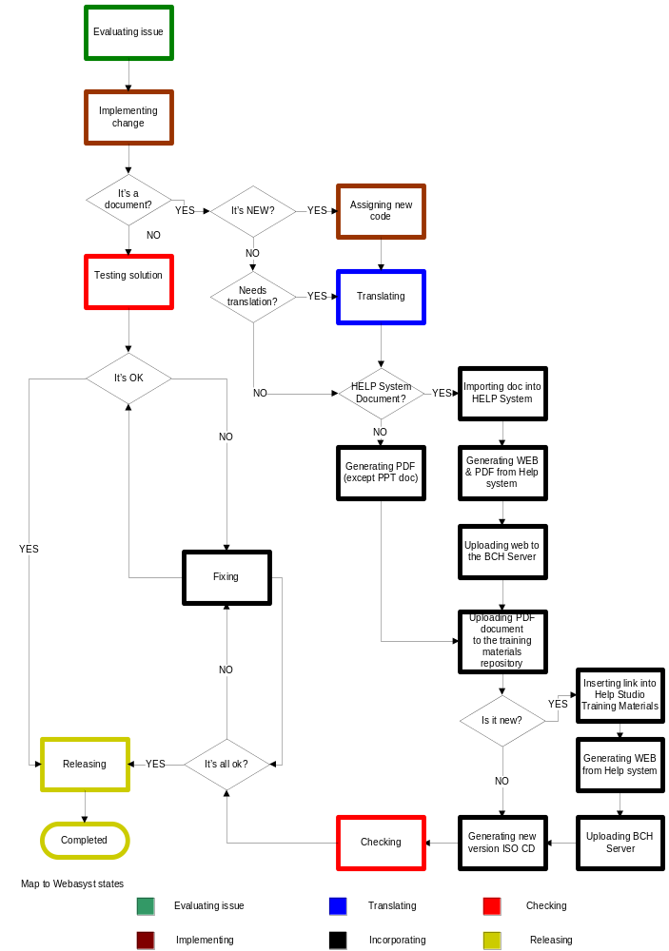

Evaluating issue:
This is the initial state, when a new issue comes in, a brief description is given for it, which must mention which the related training material is. In this state, an impact analysis must be performed for the issue, and attached to its description.

For example, if an error is reported in MO01 French version, all other languages must be checked; so the impact analysis would say that these other documents are also reached by the issue:
  - MO01 English
  - MO01 Spanish
  - …

Only when this process is complete can we move the issue to the next state.

Implementing change.
This state means that the actual changes are being made to the materials. Typically, these will be made first in English. Once this is done, if these changes need to be translated (like in the previous example), we move the issue to the “translating” state, otherwise, we go directly to “Test solution”.

Testing solution.
Once changes have been made, translated and incorporated, it is vital to do some - preferrably exhaustive – testing to ensure that no wrong modifications will go public. If what changed is a document, do careful proofreading; if it involves the HelpSystem, also do test the system in some test server (having a checklist for HelpSystem modifications would be suitable).

If no errors are detected, release the modify version (e.g. publish the new training material, publish the modified HelpSystem, etc.). If errors are detected, schedule corrections by moving the issue back to the “Implement changes” state.

Assigning new code.
Assign a document code and filename according to conventions, and update DEV.REP.04 Training material list.

Translating
This is the state than an issue will have while translators are working with documents or part of documents to make the necessary changes in all other languages.
Start always by the English version (master language)

Help System document
To import Into Help System Studio, content currently stored in a Word document, follow the process described in DEV.PR.01 Importing documents into Help Studio

Inserting a link into Help Studio.
If the document is new, you should insert into the correspondent Training Materials Topic a link that leads to it.

Generating Web and PDF form Help System.
To generate the new Web version follow the process DEV.PR.03 Working with Build Flags and Build Profiles, and for automatically generated PDF document, follow: DEV.PR.05 PDF Generation

Uploading document in moodle.
Upload the pdf or ppt document in moodle, assign the code and name file following the convention described in DEV.REP.04 Training material list

Generating a new version of ISO CD.
Generate a new ISO CD version applying DEV.PR.06 Update the CD-ROMs ISO

Checking.
Verify all products developed. If errors are detected, schedule corrections by moving the issue back to the “Implement changes” state.

Releasing.
Assign a new release identification following the convention described in DEV.IN.01 Versions and Builds.
Put a news advise in the BCH Central Portal, in order to inform about the changes, or enhancement done.

